**DOCUEMNTATION**

Having clear and consistent documentation can ensure transparency and clear communication.

It communicates key issues and solutions:

For example:

* What problem are you trying to solve?
* What are the project goals?
* What are the scope and deliverables, and who are the projects stakeholders?
* What resources do they need to complete their work?

Having this documentation allows people to understand key aspects and be communicated with easily.

It can also serve as a backup for decisions making and made in the pat and a clear reference point.

Documenting decisions can help you uncover tasks, timelines costs.

It provides a way to learn and adapt from.

Types of documentation:

* Project proposal
* Project charter

Used to communicate with stakeholders

**Project Proposal:**

A form of documentation that persuades a stakeholder to begin a project.

At the beginning of a project.

It can be different types from:

* PowerPoint
* Simple doc
* Conversation
* Email
* Etc

This is typically the first thing done, kicks off the initiation phase by influencing and persuading the company to m0ve forward with the project.

**Project charter:**

A formal document that clearly defines the project and outlines the neccary details needed to reach its goals.

It sets up a framework for what needs to be done and communicate those to others.

This is typically done after the approval of the proposal.

Its goal is to clearly define the key details of the project.

This is typically used as a reference throughout the project life cycle.

It makes clear the benefits of the project outsight the costs of the project, or the benefit of the project itself.

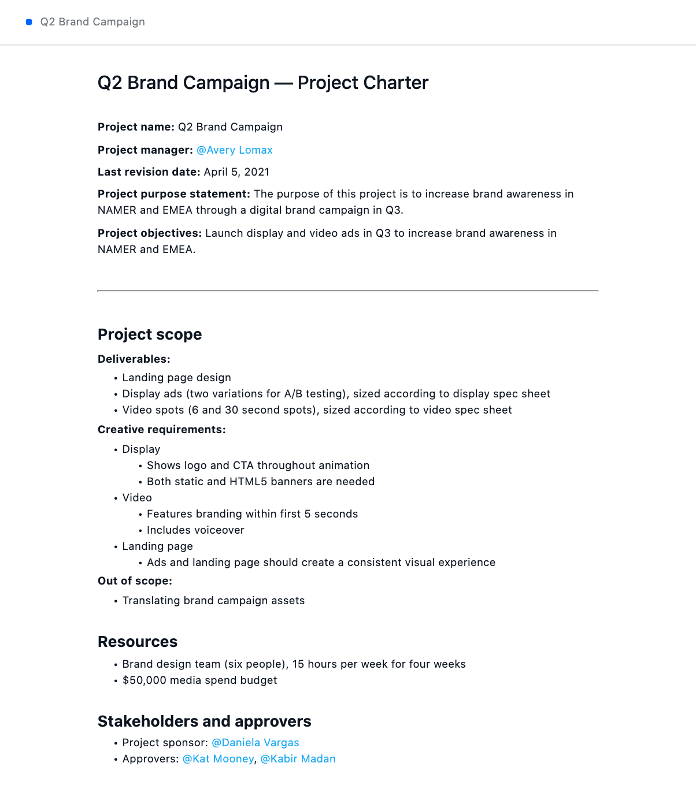

This will include the cost benefit analysis:

-

* Business value created
* Money saved
* Value brings
* Time investment
* More of this type of information

This allows you and the stakeholder to agree on the basis, ensuring you and stakeholders agree on the details of the project.

Once the charter is approved then you can move with the project.

These can be made specific to the departments affected and or the area affected for the stakeholder’s interest.

Therefore, creating a project charter is the best practice for ensuring that everyone agrees on how to move forward before entering the planning phase.

The charter itself will evolve throughout the project’s lifecycle, as the PM you will review and refine it throughout and get re-approval for it.

Creating a project charter:

**One used by google.**

* Top- Logo and name of the project
* Summary
* Project goals (SMART method)
* Project deliverable
* Business case (Reason for imitating the project)
* Cost benefit analysis in-detail
* Benefits
* Cost
* Budget needed
* Benefits should always out way the cost.
* Scope and out-of-scope (Agree upon for this project)
* Project team (Sponsor, lead, team, stakeholders)
* Measuring success. (Metrix, goal after lauch)